Sandwich & Finger Buffets
Annascatering.co.uk

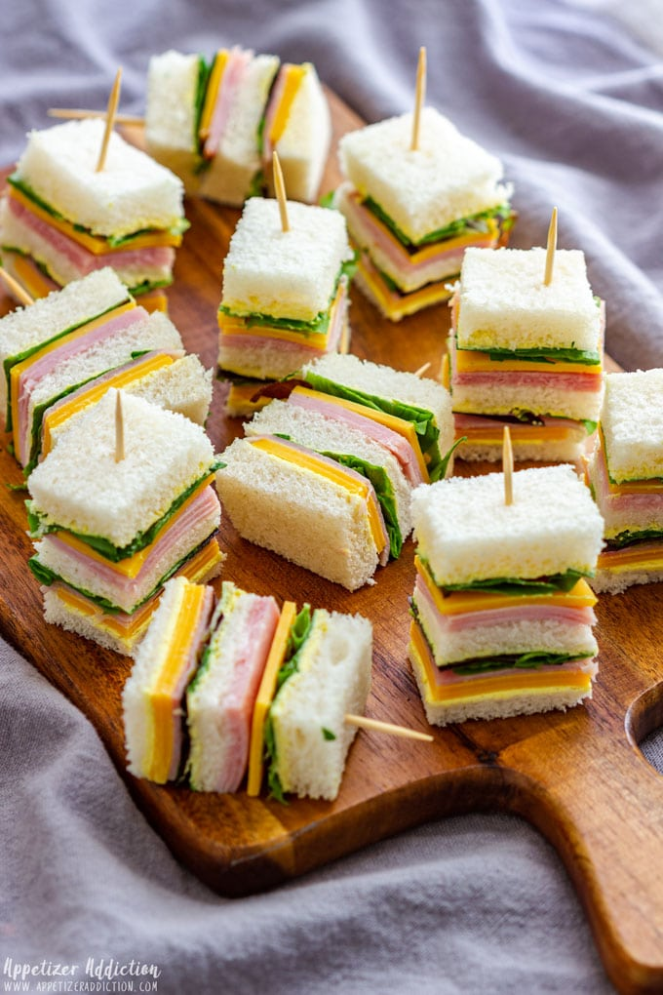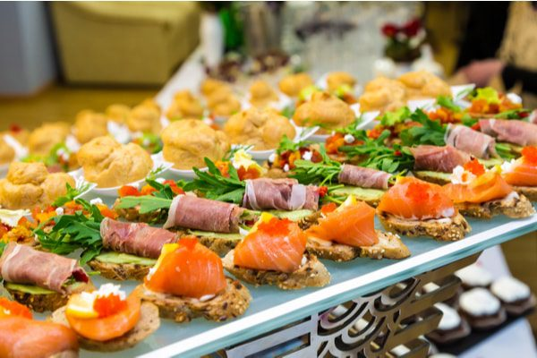

The Classic Menu @ £12/person

Assortment of Sandwiches (Honey Roast Ham & English Mustard, Tuna & Sweetcorn Mayonnaise, Farmhouse Cheddar & Pickle, Egg Mayonnaise & Cucumber)
Savouries: Handmade Cumberland sausage Rolls, Traditional individual Quiche Lorraine, Vegetable Samosas & Mango Chutney,
Cakes: Fudge Chocolate Brownie Bites, Lemon Drizzle Squares, Banana & Vanilla Buttercream Loaf; Fresh Fruit Skewers

The Deluxe Menu @ £18.50/person

Assortment of Sandwiches & Rolls: (Roast Beef, Horseradish & Rocket soft rolls, Chicken Caesar salad open sandwiches, Brie, Cranberry & Grape Crostini, Prawn Cocktail & Little Gem Wraps)
Savouries: Handmade Pork & Caramelised Onion Sausage Rolls, Roasted Mediterranean Vegetable & Goat’s Cheese Tartlettes, Lamb Kofta with a Raita Dip, Melon & Parma Ham Skewers
Cakes: Mini Victoria sponge Cakes, Millionaire Caramel Shortbread, Zesty Orange, Carrot & Walnut Squares; Fresh Fruit Skewers

The Premium Menu @ £25/person

Assortment of Sandwiches:(Duck, Hoisin & Spring Onion Croustades; Smoked Salmon & Cream Cheese Bagels; Coronation Chicken & Flaked Almond on soft white baguette; Falafel, Humous & Little Gem Croutes)
Savouries: Handmade Apricot, Rosemary & Sausage Rolls; Mini Yorkshire puddings with Roast Beef, Horseradish & Rocket; Maple Roasted Sausages with Crème Fraiche & Wholegrain Mustard Dip, Swiss Gruyère & Leek Tartlets
Cakes: Mini ‘Cream Tea’ scones with clotted cream & Strawberry Conserve; A selection of French Macarons; Glazed Raspberry & Blueberry Tarts; Belgian Chocolate & Almond Torte; Fresh Fruit Skewers

