Canapés
Annascatering.co.uk

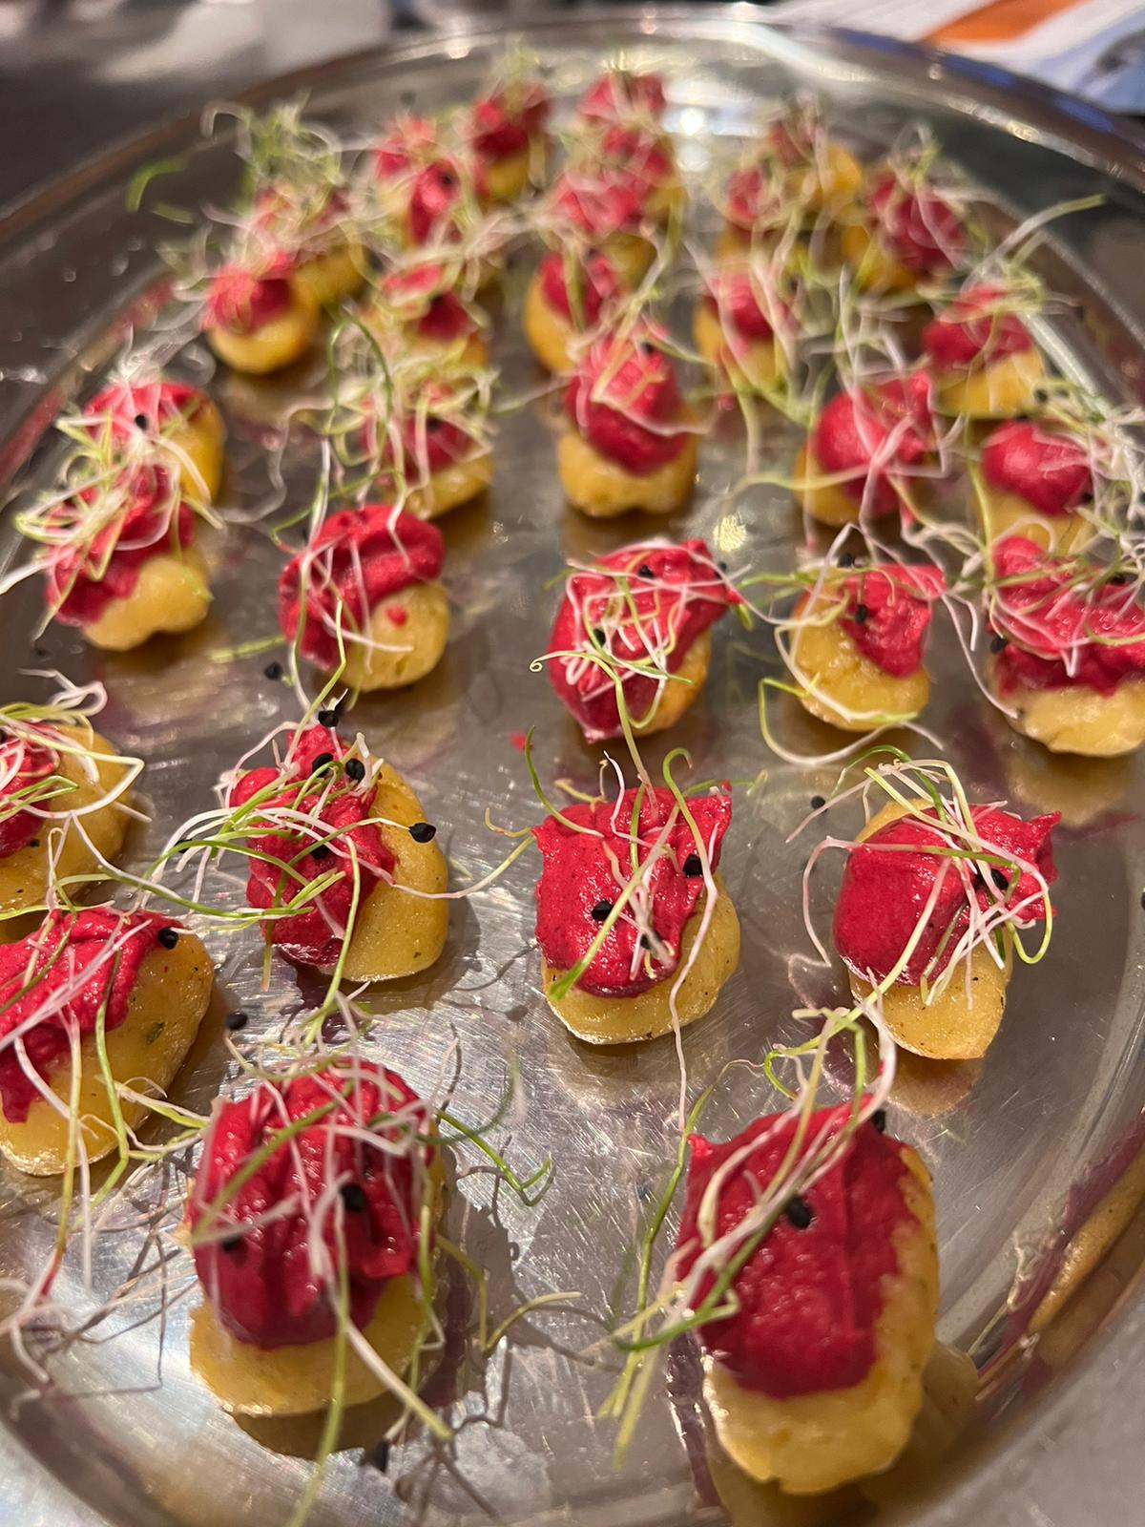

Please choose 5 canapés:

Smoked Salmon, Dill & Crème Fraiche on Rye

Rare Roast Beef, Horseradish and Thyme on mini Yorkshire Puddings

Home-made Baby Olive Scones with Herbed Garlic Cheese & Sunblush Tomatoes

Prawn & Chive Cocktail Cucumber Cups

Moroccan Lamb & Apricot Koftas with Raiita (Minted Cucumber Yoghurt)

Fresh Asparagus Spears wrapped in Prosciutto & Foaming Hollandaise

Olive Tapenade on Walnut Ficelle Bread

Honey and Wholegrain Cocktail Sausages

Wild Mushroom, Cream & Garlic Croustades

Duck & Hoisin in Filo Cups

Charentais Melon & Parma Ham ‘Heart’ Skewers

Pea Risotto Spoons

