Champagne Afternoon Tea

Whether you’re celebrating a special occasion, or just want a treat, come and join us on the terrace at Sissinghurst Castle Farmhouse for a delicious experience - £20 per resident.

A Glass of Champagne
(Nicolas de Montbart)

Choose from our selection of teas:

Assam, Ceylon, Darjeeling, Chai, Earl Grey, Mao Feng Green, Peppermint, Jasmine Pearls, English Breakfast, Matcha, Lemon & Ginger, Chamomile Flowers, Super Fruit, Cold Brew Peach & Mango

The Cake Stand

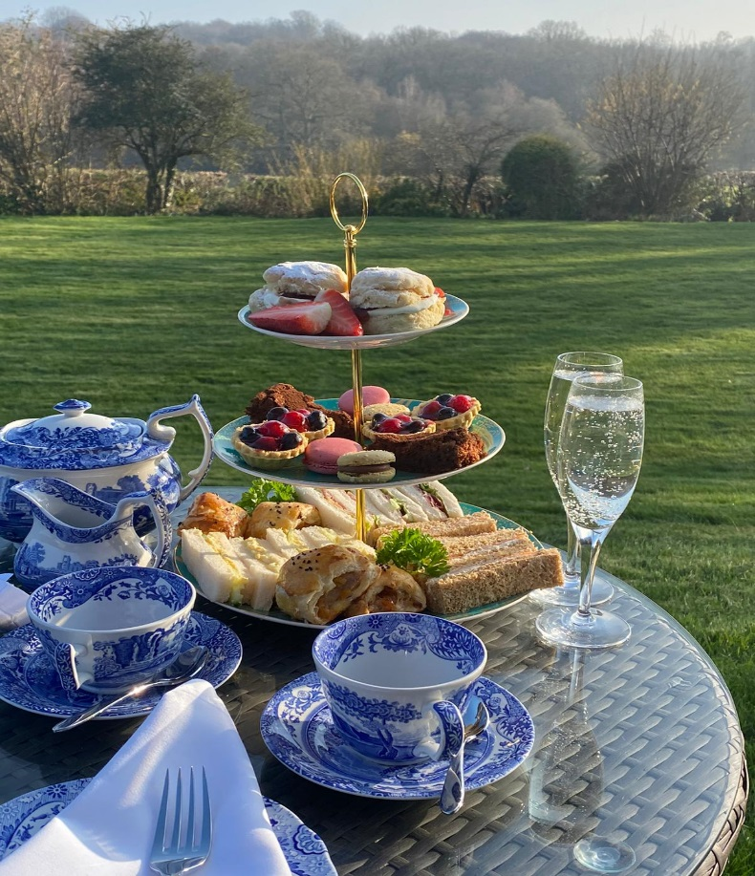
Freshly Baked Home-made Scones
with Clotted Cream and Strawberry Jam

Seasonal Fruit Tartlets

Chocolate Nemesis

Rose Petal & Pistachio Meringues

Mini Apricot & Rosemary Sausage Rolls

Finger Sandwich Selection:

Free Range Egg Mayonnaise & Cucumber
Oak Smoked Ham & Salad
Smoked Salmon with Cream Cheese

